**Software Requirements Specification for eMES**

**Table of Contents**

1. Introduction 3
   1. Purpose 3
   2. Scope 3
   3. Referenced Documents 3
2. Overall Description 3
   1. Product Perspective 3
   2. Product Functions 4
   3. User characteristics 5
   4. Operating Environment 5
   5. User Documentation 5
   6. Assumptions and Dependencies 5
3. Specific Requirements 5
   1. External Interface Requirements 5
      1. User Interface 5
      2. Hardware Interface 5
      3. Software Interface 6
      4. Communication Interfaces 6
   2. Functional Requirements 6
      1. Log In/Out 6
      2. Management of Resources 6
      3. Planning and Scheduling 7
      4. Data Collection and Acquisition 8
      5. Production Tracking, Dispatch and Traceability 9
      6. Process Management and Workflow Control 10
      7. Performance Analysis 10
      8. Quality Management 11
      9. Document Management 11
      10. Information Management 12
      11. Service Task Management 12
   3. Performance Requirements 13
   4. Database Requirements 13
   5. Quality Requirements 13
      1. Reliability 13
      2. Availability 13
      3. Security 13
      4. Portability 13
      5. Usability 13
4. **Version Control 14**

# Introduction

## Purpose

The purpose of this document is to give a description of the requirements for the “**eMES**” software. This document is primarily intended to be used to describe the main use cases as reference for the system validation.

## Scope

eMES is an Manufacturing Execution System (MES) consists of an integrated set of production activity and support applications that maintains a real-time operational database for production management and control and traceability while providing information for continuous improvement of inventory, efficiency, production cycle time, utilization, quality and productivity, … in operations.

## Referenced Documents

|  |  |
| --- | --- |
| Document # | Reference |
| [1] | Software Development Request for eMES |
| [2] | Software Validation Report eMES |

# Overall Description

This section will give an overview of the whole system. The system will be explained in its context to show how the system interacts with other systems and introduce the basic functionality of it. It will also describe what type of stake- holders that will use the system and what functionality is available for each type.

## Product Perspective

eMES is a web-based client-server system for using data from the shop floor to maintain and communicate status information on shop orders (manufacturing orders) and on work centers. Shop floor control can use order control or flow control to monitor material movement through the facility.

Externally, eMES interacts with other information systems to obtain operational related information and data which are needed for production execution. eMES interfaces with LINKQ-ERP to collect information about product, production or- der, routing, … and to synchronize production order confirmation. It connects to Human Resources database to col- lect employee master data. And it links to Door Access to obtain attendance information In and Out. In addition, eMES connects to TQM to synchronize document as well.



HR database

eMES

database server

TQM

Database

Document

on local server

eMES client

LinkQ ERP

Door access control

## Product Functions

eMES has following functionalities:

* + - **Management of Resources**: provides status of personnel in and up-to-the-minute time frame and interacts with resource allocation to determine optimal assignments. Defines and tracks the status of each resource associated with producing the production unit (production tools, machines, breakdowns, material shortage,...). Manages the necessary skills and authorizations for people, products and/or operations.
    - **Planning and Scheduling:** provides a detailed view of the planned production orders and their production routing including resource definition and allocation such as work center, production quantity, personnel as- signment, technical document,…
    - **Data Collection and Acquisition:** provides an interface link to other information systems such as LINKQ-ERP, Hu- man Resources database, Door access,… to obtain operational related information and data which are needed for production execution. Allows the input of all information during production, manually and/or automatically.
    - **Production Tracking, Dispatch and Traceability:** provides the visibility to where work is at all times and its disposition. Status information may include who is working on it; current production conditions, and any alarms, rework or other exceptions related to the product. The on-line tracking function creates a historical record which allows traceability of resource usage of each production order.
    - **Process Management and Workflow Control:** provides product information and data and process routing and operational sequencing including full traceability.
    - **Performance Analysis:** provides measurement of inventory, efficiency, product unit cycle time, utilization, quality and productivity of the workforce and machines through consolidating data to calculate the key perfor- mance indicators such as Work In Progress (WIP), Efficiency, Rework, Scrap, Process capability (Cpk), Over- all equipment effectiveness (OEE),… Provides up-to-the-minute reporting of actual manufacturing operations results along with the comparison to past history and expected business result.
    - **Quality Management:** manages the quality of manufacturing processes and units including quality deviations and exceptions. Provides real time analysis of measurements collected from manufacturing to assure proper product quality control and to identify problems requiring attention. Allows the input of all quality information during production, manually and/or automatically.
    - **Document Management:** makes available to the operator at the correct time the documents (instructions, drawings, notes,…) necessary to carry out their work.
    - **Information Management:** controls release of company information and displays it to user
    - **Service Task Management:** manages others tasks which consumes company resources but not directly re- lated to production execution, and provides control of approval process of electronic form and request.

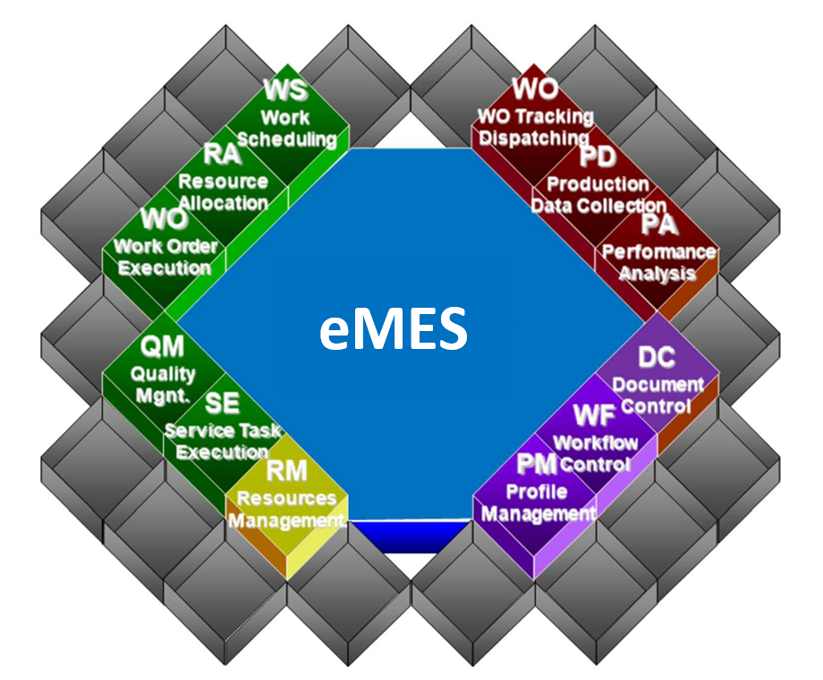

## User characteristics

There are two types of users that interact with the system: System Administrator and Users. These two types of users has different use of the function system so each of them has their own requirements.

* + - **System Administrator**: responsible for IT & administration of the system in terms of user’s authorization, trouble shooting, system maintenance, audit trail,… Maintain readiness, stability and reliability of the system but don’t involve in generation of operational data and information.
    - **User**: interacts with system functions through the interface to generate operational data and information.

## Operating Environment

Main components of eMES system includes:

* + - **Hardware:** Cisco core network, D-Link switch, Asus, Lenovo and Dell thin client, Intel database server and Intel web application server.
    - **Operating system:** Microsoft SQL Server Standard Edition, Linux Ubuntu

eMES interacts with LINKQ-ERP, Corporate TQM database, Human Resources database, and Door Access.

## User Documentation

* + - User manuals
    - On-line help
    - Tutorials

## Assumptions and Dependencies

Product functions, user characteristics and operating environment could be affected and adapted to follow changes of Corporate IT policy, and regulatory and standards or other external factors.

# Specific Requirements

This section contains the most important functional and quality requirements of the system. It gives a descrip- tion of the system and its main features.

## External Interface Requirements

This section provides a description of the hardware, software and communication interfaces and provides basic pro- totypes of the user interface.

## User Interface

User interface of eMES will be easy to use and understandable. User is expected to be familiar with web browsers to be able to explore menu and use its functions.

Key user interfaces are explained as below:

* + - 1. Login Interface

In this interface there will be two boxes of user ID and password for registration. User keys in information in these two boxes to login.

* + - 1. Browsing interface

In this interface there will be button menu representing a lot of functions. User can choose one of them to communicate to the system.

* + - 1. Confirmation interface

In this interface user types information about production order or service order and click confirm button to update the information and send it to database server.

## Hardware Interface

The eMES system is designed to work with desktop and think client provided by Local IT. Minimal screen resolution is 1920x1080 pixel. The eMES system is designed to work on web brower.

## Software Interface

There are interfaces between eMES and other systems:

* eMES interfaces with LINKQ-ERP: indirectly link through temporary data storage on local server
* eMES interfaces with TQM: directly link and connect data or through document storage on local server
* eMES interfaces with Human Resources database: directly link and connect data
* eMES interfaces with Door Access: directly link and connect data

## Communication Interfaces

eMES uses network connection to communicate server and clients. User uses web browser through network connec- tion to interact with the system. The system send information to user through Outlook email.

## Functional Requirements

* + 1. **Log In/Out**
       - **Description**: user performs Log In and Log Out into the system with their individual user ID and password.

For any transaction, user information is recorded for traceability.

* + - * **Functional Requirements**:

REQ-1: user registers user ID and password

REQ-2: if user ID and password valid then web application allowed login

REQ-3: if user ID and password invalid then web application show error message REQ-4: system records log in/ logout time

REQ-5: password is forced to be changed every certain period of time. REQ-6: user information is recorded for traceability

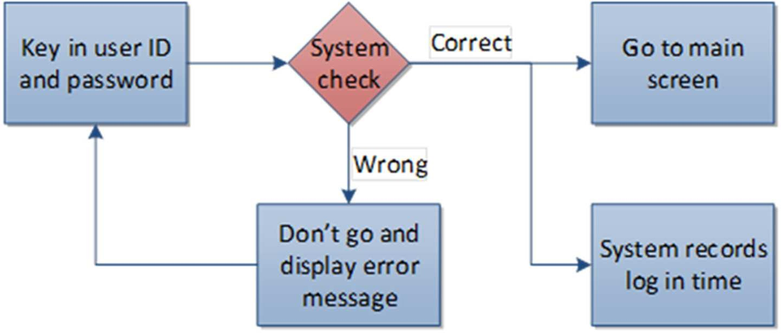

## Management of Resources

* + - * **Description**: connects to Human Resources database and Door Access to synchronize data and infor- mation to eMES database. Personnel data and information are assigned to respective production lines spec- ifying by work centers and cost centers to be used for other eMES functions. For any transaction, user infor- mation is recorded for traceability.
      * **Functional Requirements**:

REQ-1: daily connects eMES to Human Resources database to synchronize personnel data and information REQ-2: daily connects eMES to Door Access to synchronize log in and log out data

REQ-3: assigns personnel to production lines specifying by work center and cost center

REQ-4: maintains necessary skills and authorizations for people by products and/or by operations

REQ-5: calculates production capacity by group and/or work center REQ-6: user information is recorded for traceability

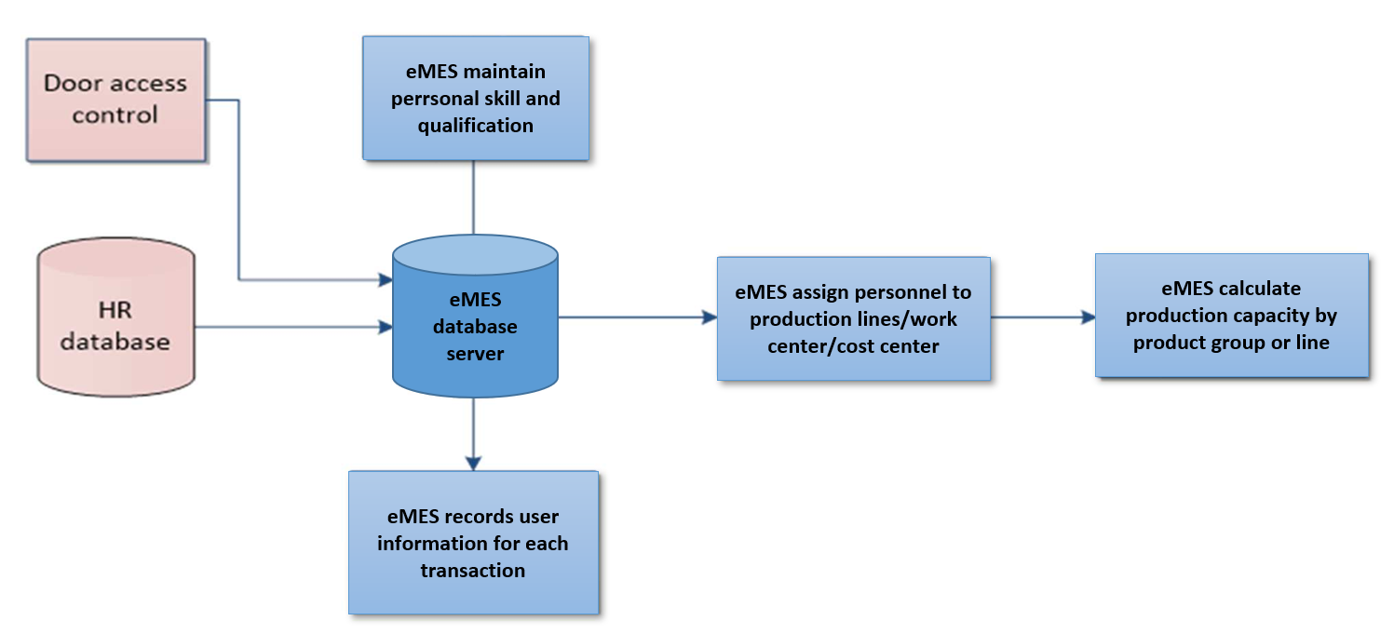

## Planning and Scheduling

* + - * **Description**: interfaces with LINKQ-ERP to collect data and information about material, released production order and routing to eMES database. At each work center, the system shows key planning information such as number of available released production order, number of required FTE, number of assigned production or- ders, number of deferred production order and reason,… For each of the released production order, the sys- tem checks the production requirement and availability of resources ranging from article number, routing, work center, work step to employee ID, personnel skill, efficiency, current workload,… Next it maps and allo- cates the released production order to available resources at each work step and/or work center. Whenever the database server updates completion confirmation of current work step, the system repeats scheduling process for next work step, i.e. check the requirement and resources in order for mapping and allocation.

The scheduling process is repeated to all work steps from beginning until end. Scheduling process is set up with different profiles which user can be authorized to choose. For any transaction, user information is rec- orded for traceability.

* + - * **Functional Requirements**:

REQ-1: daily collect data and information about material, production order and routing from LINKQ-ERP and import to eMES database

REQ-2: shows key planning information such as number of available released production order, number of required FTE, number of assigned production orders, number of deferred production order and reason,…at each work center

REQ-3: checks requirement and resources, allocates production order to operator or group of operators where available at each work step

REQ-4: scheduling process is set up with different profiles which user can be authorized to choose REQ-5: user information is recorded for traceability

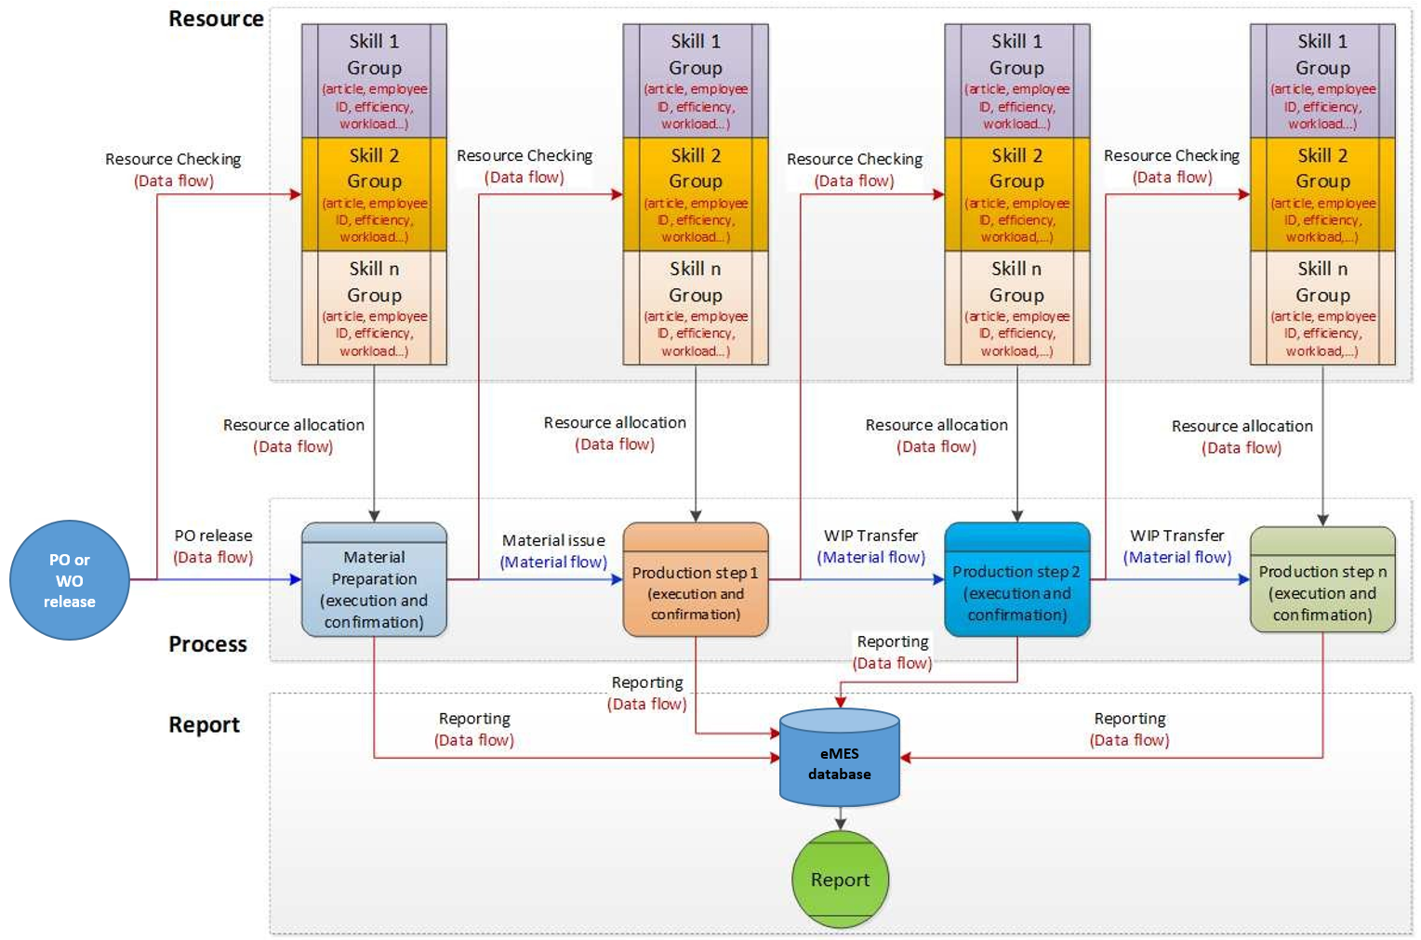

## Data Collection and Acquisition

* + - * **Description**: interfaces with LINKQ-ERP to collect data and information about material, released production order and routing to eMES database. The production order is displayed in dashboard of authorized user in eMES following detailed scheduling information. In the dashboard, user can input confirmation of completion of his or her responsible work step which is defined in routing of the product and report good quantity, defect quan- tity and also scrap. It also provide users with interface so that they can key in additional information into rec- ord of the production order. Allow user to cancel her confirmation, and add new confirmation. For any trans- action, user information is recorded for traceability.
      * **Functional Requirements**:

REQ-1: daily collects data and information about material, production order and routing from LINKQ-ERP and import to eMES database

REQ-2: user reports good quantity, defect quantity and also scrap during work step confirmation REQ-3: user keys in additional information into record of the production order

REQ-4: user inputs confirmation of completion of their responsible work step defined in routing. Confirmation data is updated to eMES database.

REQ-5: allow user to cancel confirmation and add new one REQ-6: user information is recorded for traceability

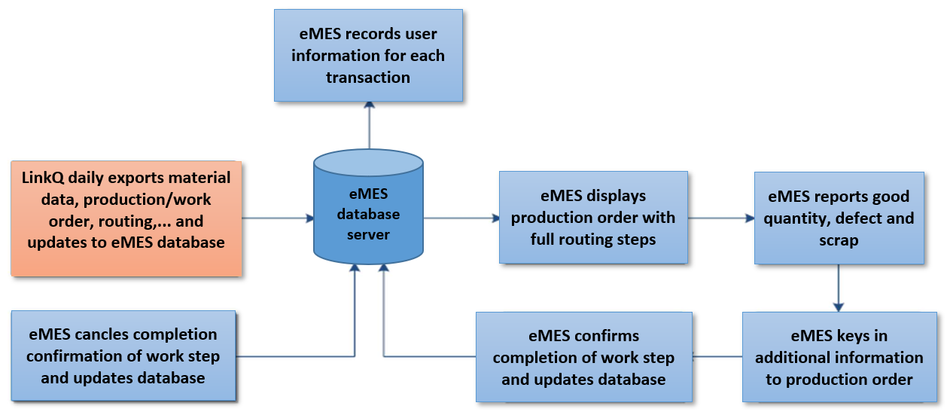

## Production Tracking, Dispatch and Traceability

* + - * **Description**: regularly provides user with status of production order and its history records. Status infor- mation may include who is working on it; current production conditions, and any alarms, rework or other ex- ceptions related to the product. The on-line tracking function creates a historical record which allows tracea- bility of resource us-age of each production order. In addition, the system also records key information about production order including the time of release, the time of completion confirmation at each work step,… For any transaction, user information is recorded for traceability.
      * **Functional Requirements**:

REQ-1: daily collects data and information about material, production order and routing from LINKQ-ERP and import to eMES database

REQ-2: user can key in production order number to query information about its status and historical records (**WHAT** is process routing, **WHO** did **WHAT**, at **WHICH** work step, by **WHEN** the work step was completed, used **WHICH** work instruction, and finished **HOW MANY** products at each work step)

REQ-3: user information is recorded for traceability

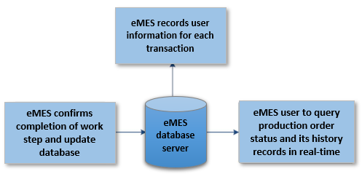

## Process Management and Workflow Control

* + - * **Description**: interfaces with LINKQ-ERP to collect data and information about material, released production order and routing to eMES database. Changes of material, process and routing in LINKQ-ERP is required to update timely and automatically to eMES database. User can create and edit workflow for special processes such as repair and rework. For any transaction, user information is recorded for traceability.
      * **Functional Requirements**:

REQ-1: daily collects data and information about material, production order and routing from LINKQ-ERP and import to eMES database

REQ-2: update timely and automatically changes of material, process and routing in LINKQ-ERP to eMES database REQ-3: user can create and edit workflow for special processes such as repair and rework

REQ-4: user information is recorded for traceability

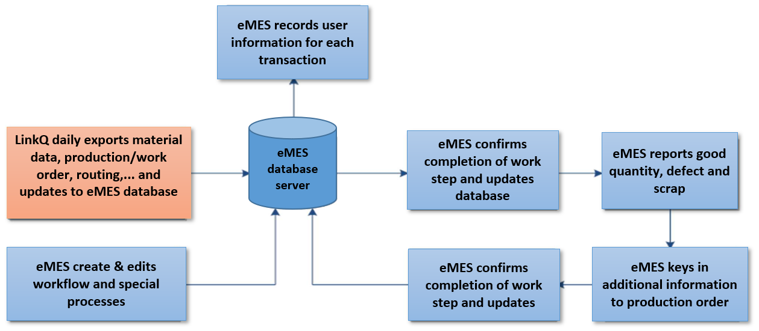

## Performance Analysis

* + - * **Description**: provides measurement of inventory, efficiency, product unit cycle time, utilization, quality and productivity of the workforce and machines through consolidating data to calculate the key performance indi- cators such as Work In Progress (WIP), Efficiency, Rework, Scrap, Process capability (Cpk), Overall equip- ment effectiveness (OEE),… Provides up-to-the-minute reporting of actual manufacturing operations results along with the comparison to past history and expected business result.
      * **Functional Requirements**:

REQ-1: hourly reads database and automatically generates performance reports and updates them to perfor- mance dashboard and in parallel send them via user’s email

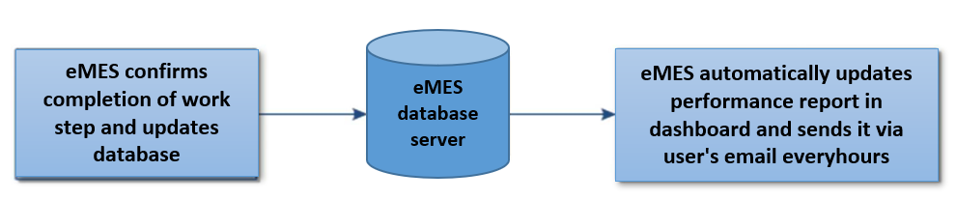

## Quality Management

* + - * **Description**: allow user to maintain defect master data and update it time by time. Provides user with inter- face to key in quality data for each of work step including defect type, defect mode, defect description, defect quantity,... User can input additional information into quality record of the production order. In addition, the system can interact with other external systems to collect quality data and information which arises from exe- cution of production order. The system automatically updates quality report and user can access to the re- ports timely. For any transaction, user information is recorded for traceability
      * **Functional Requirements**:

REQ-1: maintains defect master data and update it time by time

REQ-2: user keys in quality data for each of work step including defect type, defect mode, defect description, defect quantity,...

REQ-3: user can input additional information into quality record of the production order REQ-4: interact with other external systems to collect quality data and information REQ-5: user can access to quality reports which are automatically updated in real-time REQ-6: user information is recorded for traceability

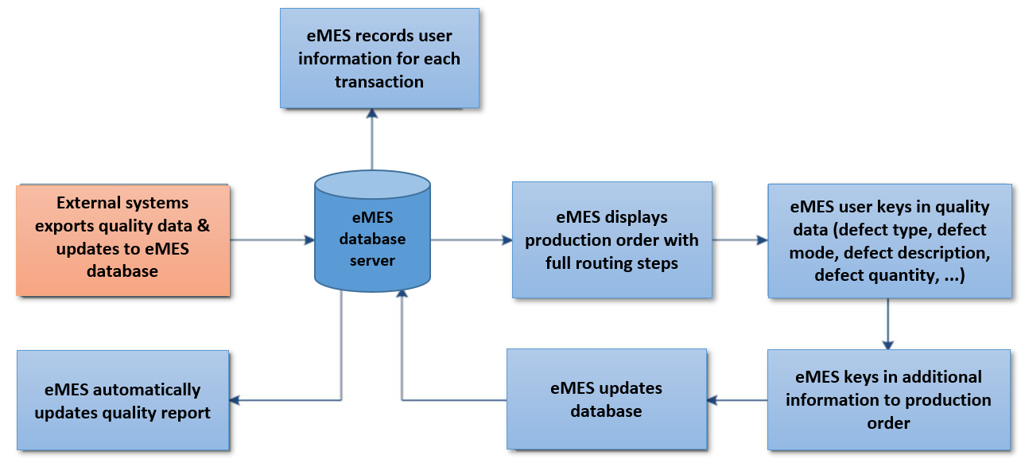

## Document Management

* + - * **Description**: interfaces with TQM database to synchronize active documents or directly links to TQM data- base.
      * **Functional Requirements**:

REQ-1: documents are synchronized with TQM database and posted automatically or manually in eMES by authorized user

REQ-2: system automatically creates direct link to document in TQM database REQ-3: user information is recorded for traceability

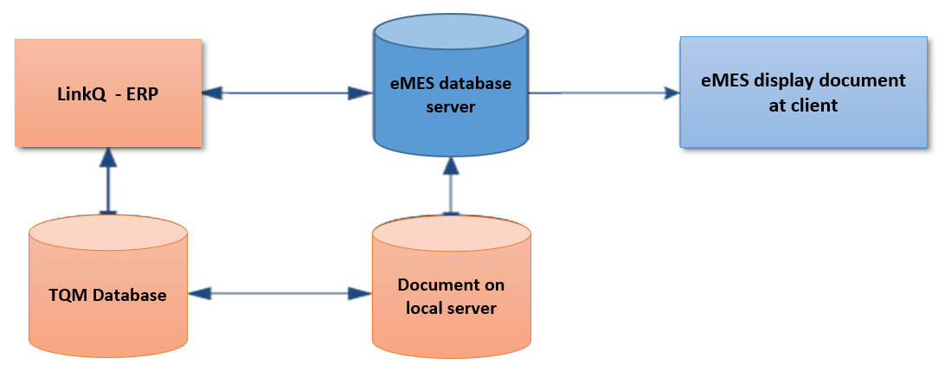

## Information Management

* + - * **Description**: authorized user posts and releases information which is displayed in Company information board. This board can be accessed by all users.
      * **Functional Requirements**:

REQ-1: authorized user posts information REQ-2: system check

REQ-3: if OK then displays information in Company Information REQ-4: if not OK then displays error message

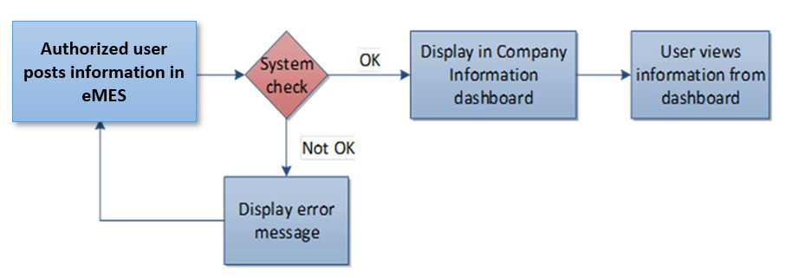

## Service Task Management

* + - * **Description**: user creates service order whose tasks consume company resources but not directly related to production execution in the system using default pre-defined work steps or free definition. Service order is treated as production order which means key functions such as tracking, searching for historical records, adding information, reporting performance,…. are available.
      * **Functional Requirements**:

REQ-1: user can create service order either by using default pre-defined work steps or free definition

REQ-2: sets up tracking, searching for historical records, adding information, reporting performance,….same as production order

REQ-3: user information is recorded for traceability

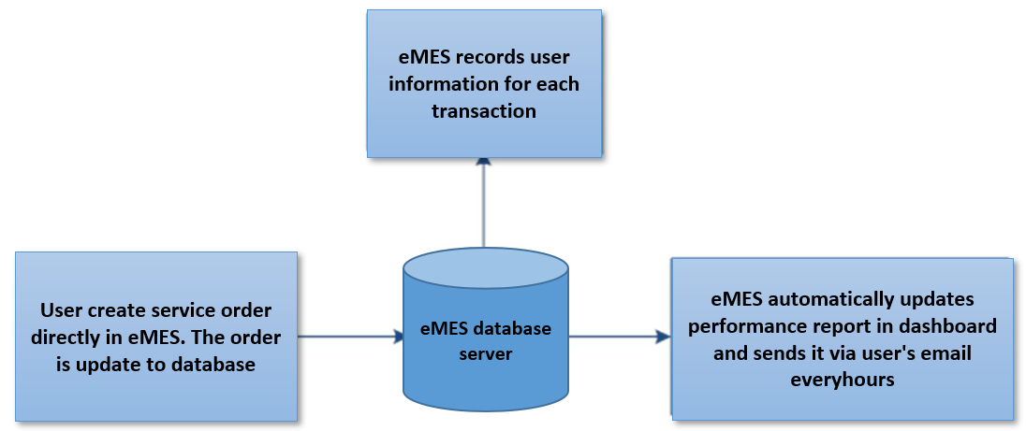

## Performance Requirements

The system is required to support multiple terminals simultaneously. The system should handle reasonable number of users without break or inconsistency.

## Database Requirements

Database should meet the following criteria:

* + - Consistent data in a concurrent environment
    - Data integrity
    - Basic and complex data types
    - Data access by the end users
    - Version control of configuration management
    - Tool development
    - Documentation
    - Traceability

## Quality Requirements

This section includes the requirements that specify all the quality relevant topics of the software system.

## Reliability

The system should work reliably, with automatic backup and recovery features. In case of unexpected termination of a session, the unsaved data will be lost.

## Availability

The entire system should be available round the year, except for a periodic maintenance. The maintenance period should be pre-scheduled and short. The users should be reminded of the unavailability period, well in advance.

* + 1. **Security**

The system, at any time, should be accessed only by the authenticated users. Network communications should use cryptographic protocols such as SSL. The system is required to end the session automatically, when an open session is not used for a specific period of time.

* + 1. **Portability**

The system should support new versions of the related database architecture. The administrative and server technol- ogies should be standard and supported by most platforms.

* + 1. **Usability**

The GUI should be easy to learn and use by users of any technical background. A built-in help feature should be available in all pages, to guide the users with the available functions on that page. An easy to understand documenta- tion should be provided with the system. System language should be English and Vietnamese.

1. Version Control

|  |  |  |  |  |  |  |
| --- | --- | --- | --- | --- | --- | --- |
| LỊCH SỬ SỬA ĐỔI/ *CHANGE HISTORY* | | | | | | |
| Ngày ban hành  *Issue date* | Phiên bản  *Version* | Nội dung thay đổi  *Change of content* | Lý do thay đổi  *Reason for change* | Soạn thảo  *Prepared by* | Xem xét  *Reviewed by* | Phê duyệt  *Approved by* |
| 01/11/2023 | A | Tạo mới  New issue | - | Tonny Bui | - |  |
|  | | | | | | |